1.A man deposit 10% of his salary in PF. He saves 30% of the remaining. The ratio of his expense on medicine and groceries is 3 :4 of the remaining salary after saving. If his expense on the medicine was Rs 2700. Find the monthly salary.

1. Rs 10,000

2. Rs 15,000

3. Rs 30,000

4. Rs 20,000

5. None of these

Solution:

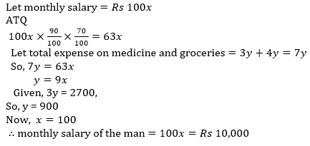

2.In a mixture of milk and water, the proportion of milk by weight is 60%. If from the 80 gm mixture, 20 gm of mixture is taken out and 6 gm of pure water is added to the mixture then find the ratio of milk and water in the new mixture.

1. 5 : 6

2. 6 : 5

3. 4 : 3

4. 3 : 2

5. 7 : 6

Solution:

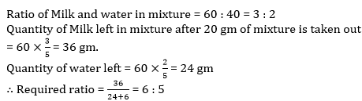

3.A certain amount was distributed among A, B and C in the ratio 1 : 3 : 5 but it was actually distributed in ratio 2 : 3 : 6 due to which B got Rs 42 less. Find the amount actually to be received by A.

1. Rs 66

2. Rs 77

3. Rs 84

4. Rs 126

5. Rs 154

Solution:

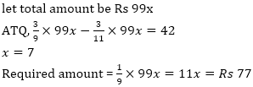

4.A sum of money is divided among P, R,T and Z in the ratio 4 : 7 : 9 : 14. If the share of P and R is Rs 4604 more That T, then what is the total amount of T and Z together.

1. 52946

2. 31223

3. 40232

4. 32321

5. 35212

Solution: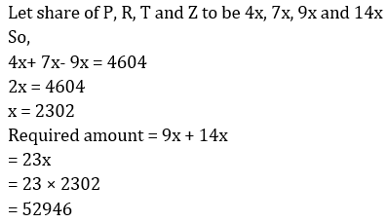

**5.**The ratio of the prices of two houses A and B was 4 : 5 last year. This year, the price of A is increased by 25% and that of B by Rs. 50,000. If their prices are now in the ratio 9 : 10, the price of A last year was :

1. Rs. 3,60,000

2. Rs. 4,50,000

3. Rs. 4,80,000

4. Rs. 5,00,000

5. Rs. 3,30,000

Solution: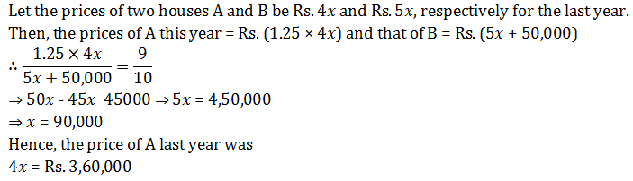

**6.**A vessel contains liquid P and Q in the ratio 5 : 3. If 16 litres of the mixture are removed and the same quantity of liquid Q is added, the ratio become 3 : 5. What quantity does the vessel hold?

1. 35 litres

2. 45 litres

3. 40 litres

4. 50 litres

5. 60 litres

Solution: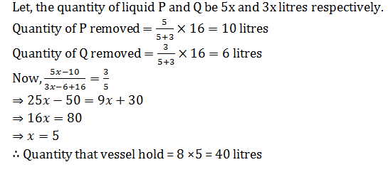

7.Ratio of present ages of A and B is 16:7. After 12 years, A’s age is twice of B’s age then find present ages of A and B?

1. 64yr; 28yr

2. 80yr; 35yr

3. None of these

4. 96yr; 42 yr

5. 102yr; 49yr

Solution: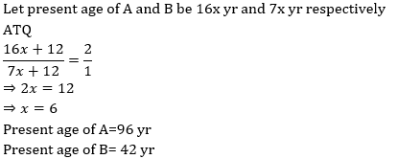

9.A mixture contains wine and water in the ratio 5 : 1. On adding 5 litre of water, the ratio of wine to water becomes 5 : 2. The quantity of wine in the mixture is ?

1. 20 l

2. 22 l

3. 24 l

4. 26 l

5. None of these

Solution: